### Remote Data Logger Tutorial

#### Background

**Overview**

This tutorial explains how to run a basic demo of our Remote Data Logger. The Remote Data Logger stays in low-power “sleep” mode, and wakes up every few minutes or hours to collect data from its sensors. It can transmit its data via WiFi, or by sending them directly to a “collector” device.

[insert notional diagram]

The tutorial covers how to make a standard device that has one sensor, one display screen, and an infrared-based triggering circuit. However, the device is very modular: you can equip it with your own sensors or your own triggering circuit, and modify the code accordingly.

**Detailed device specs and parts list**

The device has two modes: an indoor mode where the sensor uses the WiFi network to upload its data to a server, and an outdoor mode where the sensor saves all its recordings. In outdoor mode, the device only wakes up when it is triggered by a signal from a collector device, just like a TV remote control powers on a TV. It sends data directly to the collector device, and the collector device uploads all the data to the server using WiFi.

The core of the device is an ESP 32 development board, which controls the device. There is a pressure, humidity, and temperature sensor, and an OLED display screen. The device uses a protocol called I2C to communicate with the sensor and the OLED. It has an infrared receiver module that allows the collector device to “trigger” the device, or wake it up from a distance. It has two buttons: one that allows the user to toggle between the two modes, and one that “triggers” the device in the same way the IR signal would.

You’ll need the following parts to assemble this board:

* 1 ESP 32 DevKit board, $14.99. https://www.amazon.com/MELIFE-Development-Dual-Mode-Microcontroller-Integrated/dp/B07Q576VWZ/ref=sr_1_3?dchild=1&keywords=esp32&qid=1614190703&sr=8-3
* Amazon weather station, $22.99. https://www.amazon.com/dp/B07T2KFD4M/ref=cm_sw_r_cp_apa_fabc_6AV9CY91X9MPGW09A8SY
  + 1 BME280 sensor
  + 1 SH1106 OLED mini display screen
* 1 HX-M21 IR Receiver module, $7.99. https://www.amazon.com/Digital-Receiver-Transmitter-Arduino-Compatible/dp/B01E20VQD8/ref=sr_1_5?dchild=1&keywords=arduino+ir+38khz&qid=1614191863&sr=8-5
* 3-battery holder and 3 batteries (AA or AAA), $9.99. https://www.amazon.com/LAMPVPATH-Battery-Holder-Switch-Leads/dp/B07JF3DD9Q/ref=sr_1_9?dchild=1&keywords=3+aaa+battery+holder&qid=1614191703&sr=8-9
* 1 pre-built printed circuit board (PCB).

If you’re assembling on a breadboard instead of a PCB, you’ll need the following additional components:

* Solderless breadboard (x2). $9.99 https://www.amazon.com/dp/B01EV6LJ7G/ref=redir_mobile_desktop?_encoding=UTF8&aaxitk=IBR.z0Y.4NCvWJVp3bQxxQ&hsa_cr_id=1434913550101&pd_rd_plhdr=t&pd_rd_r=7f730906-3b69-4ff1-84da-695a7e8aba46&pd_rd_w=TmP9p&pd_rd_wg=xajaE&ref_=sbx_be_s_sparkle_mcd_asin_2_img
* Electronics starter kit, $17.99. https://www.amazon.com/gp/product/B07Z1BK7NG/ref=ppx_yo_dt_b_asin_title_o06_s00?ie=UTF8&psc=1
  + Jumper wires
  + 2.4K Ohm resistor (x2)
  + 10K Ohm resistors (x3)
  + 100K Ohm resistor (x1)
  + 2N2222 Transistor (x1)
  + Tactile push buttons (x2)

#### Hardware

If you’re using a PCB:

1. **Mount the PCB**

Assembling the hardware is easy with our PCB. First, push the ESP board into the 15-hole connectors on the *back* (which has the drone logo).

1. **Mount the OLED, BME, and IR on the front**

Push these sensors in the labeled spots. Make sure the labels on the PCB match the labels on the devices.

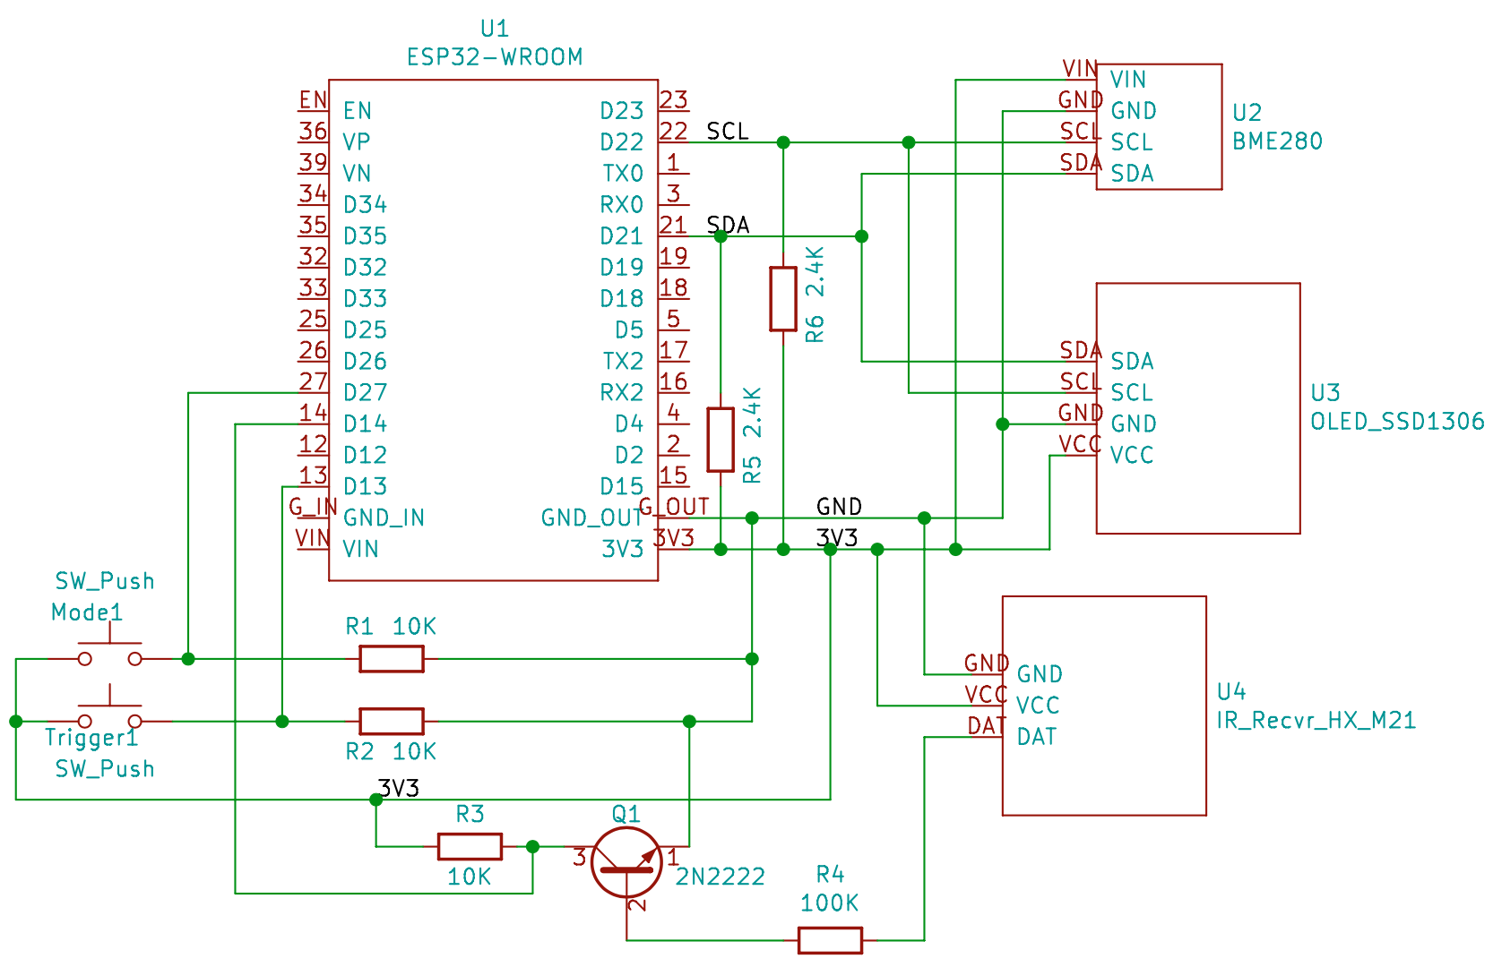

If you’re using a breadboard, you’ll be wiring up this diagram. We’ll walk you through it step by step with photos.

1. **Put the ESP32 into two breadboards:** the left pins on one breadboard, and the right pins in another.The pins are (annoyingly) spaced too far apart to fit into one breadboard while leaving room for jumper wires, so we need to use two.
2. **Connect the power pins**. Connect the pin labeled “3.3V” to the long, vertical row of pins on the side of the breadboard, and the pin labeled “GND” to the second vertical row. These are called the *ground and* *power rails*. The vertical rows might be colored or labeled red for power and blue for ground, but it depends on your breadboard. If your board has multiple power/ground rails, connect the power rails together, and ground rails together.
3. **Plug in the BME sensor.** Put the BME into a set of four adjacent pins. Remember that pins on the breadboard are connected to each other horizontally, so place the BME vertically, so its four pins are *not* connected to each other, like so:

Also make sure not to overlap the BME pins with the ESP’s pins!

1. **Wire the BME sensor**. Connect VIN to the power rail and GND to the ground rail. Connect SDA to the ESP’s Pin 21, and connect SCL to the ESP’s Pin 22.
2. **Plug in and wire the OLED**. Plug in the OLED horizontally, just like you did for the BME. Just like the BME, connect VIN to power, GND to ground, SDA to Pin 21, and SCL to Pin 22.
3. **Pull up the I2C line.** Those SDA and SCL connections are used to send data to the ESP device using a protocol known as “I2C.” When no data is being sent, the lines are “pulled high,” which means their voltage is equal to 3.3V volts instead of ground. To do this, we’re going to add “pull-up resistors” on the SDA and SCL lines. Connect one end of your 2.4K Ohm resistor to Pin 21, and connect the other end to Power. Do the same for Pin 22.
4. **Place the button.** Put the button in between two halves of one breadboard, like this:

Two sides of the button are already connected to each other, as shown in the diagram. When you click the button, it connects the two sides together.

1. **Wire the button**. Connect one side of the button to power. Connect one side of the 10K resistor to the other side of the button, and connect the other side of the resistor to ground. Finally, connect the second side of the button (the one that’s connected to the resistor) to Pin 27.
2. **Wire another button**. Repeat steps 7 and 8 above, but connect to Pin 13 instead.
3. **Place a transistor.** Bend the pins of the transistor so that they can all fit into the breadboard. The “emitter” is the pin on the left if you’re facing the flat side of the transistor, and the “collector” is the pin on right.

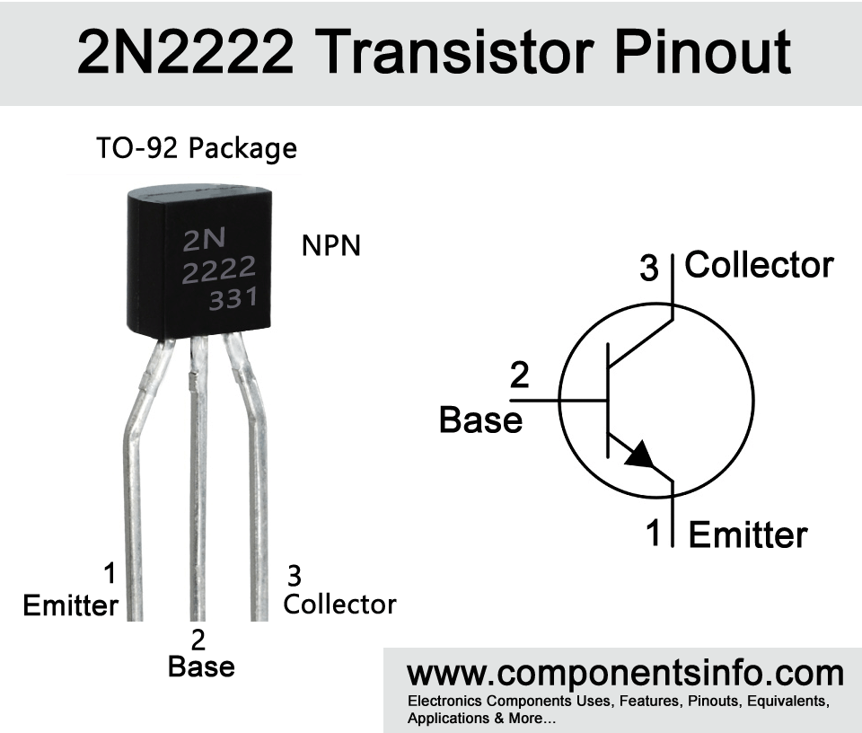

1. **Wire the transistor.** Connect the emitter to ground. Connect one end of a 10K Ohm resistor to power, and the other end to the collector. Connect the collector to Pin 14.
2. **Place the IR Receiver.** Just like the OLED and BME sensor, place it horizontally.
3. **Wire the IR receiver.** Connect VIN to power and GND to ground. Connect one side of a 100K Ohm resistor to the DAT pin, and the other side to the base of the transistor (the middle pin).

#### Software: setup

1. **Set up your Arduino IDE to use ESP-32**

Follow the instructions here to tell your Arduino application how to program the ESP-32: https://github.com/espressif/arduino-esp32/blob/master/docs/arduino-ide/boards_manager.md

1. **Install the required libraries**

In the ribbon at the top, click “Tools,” then “Manage Libraries.” Enter the following libraries in the search bar, and hit install:

“WiFi” (this may already be built in)

“HTTP Client” (also may already be built in)

“Adafruit BusIO”

“Adafruit Unified Sensor”

“ESP8266 and ESP32 OLED driver for SSD1306 displays”

“Adafruit BME280”

1. **Load our generic demo code**

Add how we are distributing the code…

1. **Quick start: edit the demo code**

You need to fill a few fields in the demo code based on your own device. You’ll need to edit the WiFi settings, latitude and longitude, and sensor ID. Put in the name and password for your WiFi network. Give your sensor any ID you want – like your own name. You can find your latitude and longitude on Google Maps.

//WIFI SETTINGS

const char* ssid = "YOUR_WIFI_NETWORK_NAME";

const char* password = "YOUR_WIFI_PASSWORD";

const String sensor_name = "SENSOR_ID";

float lat = LATITUDE;

float lon = LONGITUDE;

If you want to change how often your device sleeps and wakes up, you can do it here. It governs how many seconds the device sleeps between wake-ups.

#define TIME_TO_SLEEP 30

1. **Upload your code**

Once you’ve made those edits, connect the ESP 32 to your computer using a USB cable. Then, in the Arduino IDE, go to Tools > Ports > select the USB port your device is connected to. Click the right-facing arrow icon in the top left corner.



You should see a message at the bottom that your code is compiling, and then orange messages that it’s writing to the ESP-32.



1. **Test the device!**

Keep your device connected to power (either battery or the USB cable), and wait a few minutes for it to collect a few sensor measurements. Then, press the Trigger button. The device should display the last few measurements as a graph on the screen.

#### Software: details

Let’s dive into what the code is doing, step by step. We’ll start with the setup() function.

1. **How recording data works.**
   1. **Remembering data when we sleep**. Our device is designed to go to sleep when it’s not doing anything. When the device sleeps, any variables, arrays, or other information created in the code will be lost. However, the ESP32 has a special segment of RTC (Real-Time Clock) Memory, which stays alive even when the device is asleep. All you do to save a variable in RTC Memory is add RTC_DATA_ATTR when declaring the variable: RTC_DATA_ATTR int x; However, RTC memory is very limited (only about 4 kilobytes), and if we exceed our use of the RTC Memory buffer, our code won’t compile. We have to be careful to limit our use of the RTC Memory when possible.
   2. **How we record measurement data.** To keep track of what kinds of data we’re recording, we use a struct called a Measurement. We want to create an instance of a Measurement for each kind of measurement we’ll be taking: for instance, one for temperature, one for humidity, and one for air pressure. The temperature Measurement object keeps track of the minimum value of the measurement (e.g. -40*C), the minimum increment the sensor is capable of recording (e.g. the sensor can detect a change of 0.1*C or greater), and the name of the measurement and unit (e.g. “temperature” and “Celsius”).
   3. **Storing the data**.Because of how limited the RTC Memory is, we want to store data in the most efficient form possible. Most measurements will be given in the float data type, which costs 4 bytes. This code has a special format of representing floats as 2-byte integers. Given the minimum value and increment for a measurement (e.g. -40*C and 0.1*C), we convert any measurement into an integer number of “steps” away from the minimum. For example, 12.7*C with a min of -40*C and an increment of 0.1*C would be equal to 527 because (12.7*C – (-40*C))/0.1*C = 527.

The code already has functions that convert between the different representations for you, so there’s no need to interface with this special storage format unless you want to change the format yourself.

* 1. **Transmitting data on ESP-Now.** The ESP-Now protocol requires us to send raw bytes. Each message, or “packet’ is limited to 250 bytes, so this compact data representation is also helpful for reducing the number of packets we need to send to the receiving device. However, the receiver has to know how to convert *back*! We accomplish this by adding the code for decoding the data in the receiver’s code. Since decoding the data requires knowing what types of measurements we’re receiving, we need to include this in the receiver code as well.

1. **The setup() function.** If you’ve used Arduino before, you’ll notice something odd: the loop() function is empty! This is because when we put the device to sleep, the device will just run the setup() function, and sleep at the end of that function. It never reaches the loop() function at all! All the main code is inside of the loop() function.
2. **Opening the Serial connection**. We start the Serial connection at a rate of 115200 baud. Serial is how the ESP sends data to display on our computer. We pause the code for 100 milliseconds to let the Serial initialize.

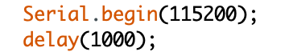

1. **Get the reason the device woke up**, using esp_sleep_get_wakeup_cause; and get the pin number that woke us up using get_wakeup_pin_number (which will be 0 if we woke up using the timer instead of a pin).

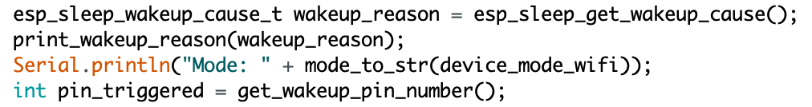

1. **Decide what to do based on the reason we woke up.**

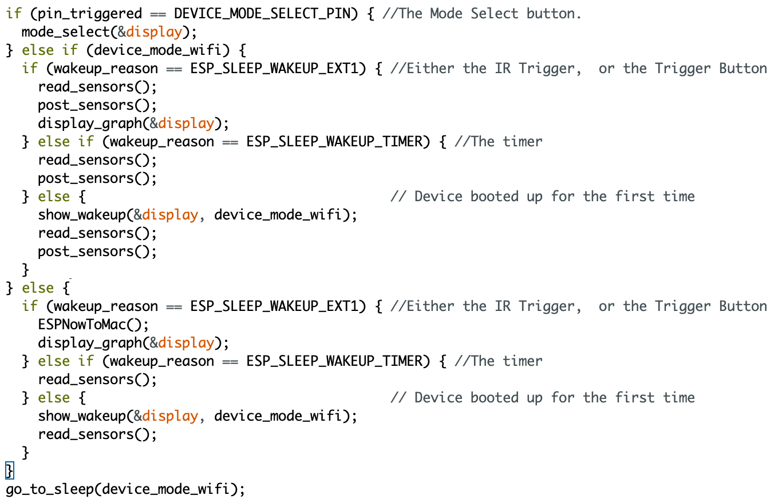

If it was the mode select pin, allow the user to change the mode using mode_select.

Otherwise, what we do depends on the mode we're in.

In Wifi mode:

if we woke from the trigger button, read the sensors, post to the server, and show the graph

if we woke from the timer, read and post but don't show the graph

if we're waking up the first time, display that on the OLED

In Trigger mode:

if we woke from the trigger button, immediately send the data using ESP-Now, and show the graph

if we woke from the timer, just read the sensors

if we're waking up for the first time, display that on the OLED

1. **Go to sleep** at the very end, using go_to_sleep.
2. **Selecting the mode**.

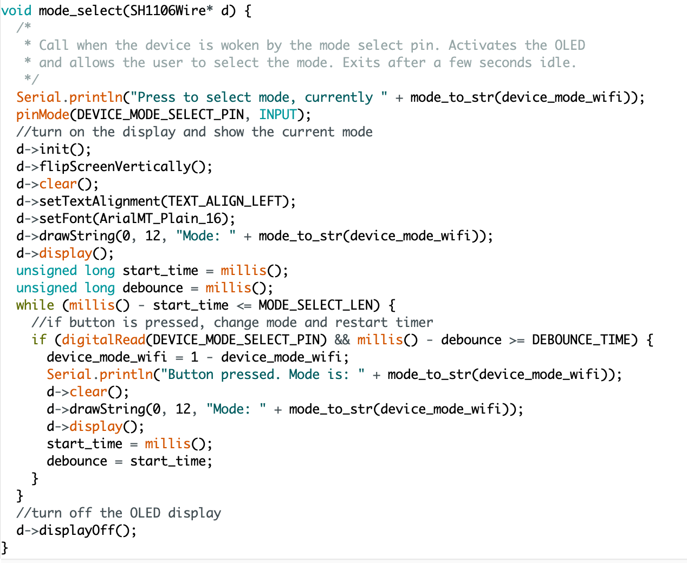

You likely won’t need to edit this, so we’ll keep it short. The code first starts up the display screen. It stays in the while loop, allowing the user to change the mode by pressing the button, and exits only when 4 seconds have passed since the last button press. Button presses are ignored if fewer than 400 milliseconds have passed since the last button press (otherwise, a single button press “bounces” and will count as hundreds of button presses!). If the button is pressed, we change the mode and show it on the display screen.

1. **Reading the sensors.**
   1. **Take measurements.**

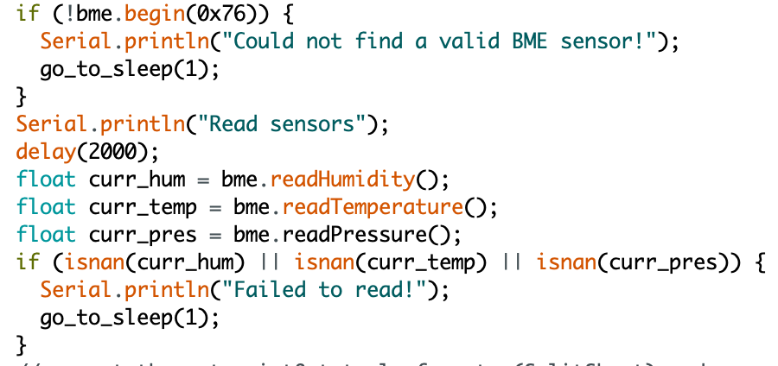

The first half uses the sensor’s built-in library to initialize the sensor using bme.begin(0x76), where 0x76 is the “address” of the sensor in hexadecimal. We check if the sensor successfully initialized; if it didn’t, we go to sleep. Then, we read the measurements of the sensor using bme.readHumidity, readTemperature, and readPressure. We check if any of these measurements are invalid using isnan (“Is Not a Number”); if they are, we just go to sleep. Modify this part of the code if you’re using another sensor.

* 1. **Record them in our data buffer.**

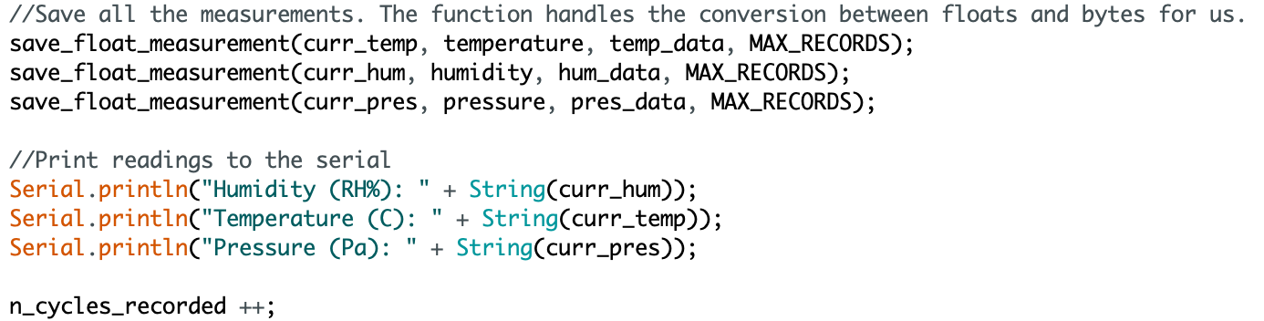

The code uses two 8-bit integers to represent each measurement. You can read the code to see how that works, but for now, you can just use the float_to_short method, supplying the measurement value and the type of measurement, to convert them into the proper format. Then, we need to save the data in our data buffer, so that we can keep track of all the past measurements even after we go to sleep. Use push_back_short to save the measurement, passing in the array to save the data, the data to save (of type SplitShort – make sure to convert it first!), and the length of the array (which is MAX_RECORDS). At the end, increment the number of measurements we’ve taken (this will come in handy later!)

1. **Posting sensor data to the server**. This is fairly straightforward. First, we use connect_to_server to establish a server connection, and configTime to figure out what time it is, using Wifi. We retrieve the last measurement with last_float_from_data; the arguments are the array to draw from and the measurement type. 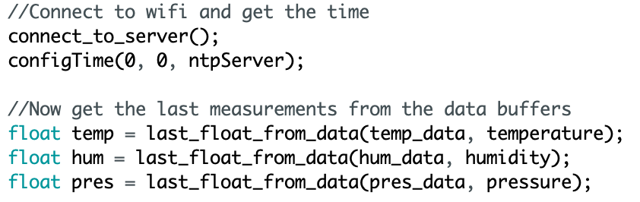

We convert each float into a String formatted in a way that works for the server using create_post_string (see the function definition for what arguments to supply). We prepare a Batch Post by putting all the strings we need in an array. Then we combine that array into another string using multi_post_string. Finally, we call http.POST with the resulting string. We check for an error—which occurs if the response from POST is anything but 200—and close the connection using http.end(). 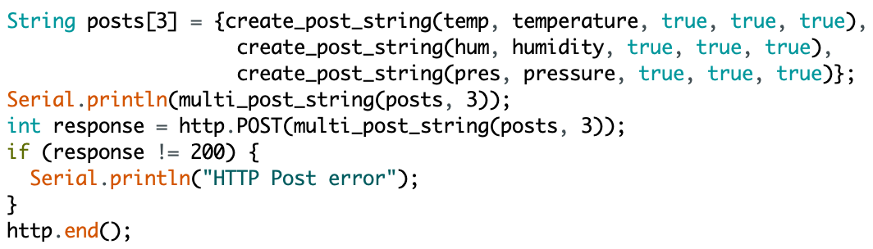

1. **Sending data on ESP Now.** [TODO AFTER DEBUGGED]
2. **Going to sleep.** This is an important function! First, we flush the serial and power off what we don’t need.

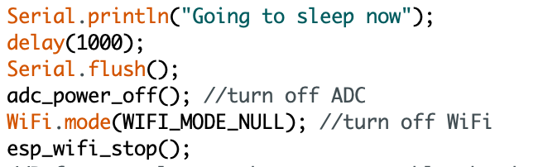

Before we actually sleep, we have to tell the sensor how it will wake up next time. First, tell the device that it should wake up from the timer. The unit is microseconds; TIME_TO_SLEEP * uS_TO_S_FACTOR (which are both defined at the top of the code) tells us how many microseconds to sleep for. Next, we tell the device to wake up from a specific set of pins, or ext_1_wakeup. The set of pin is determined by WAKE_PIN_BITMASK (also defined at the top of the code). Its value is equal to 2A + 2B + 2C…, where A, B, C are the pin numbers of the pins that we want to wake the device up.

ESP_EXT_1_WAKEUP_ANY_HIGH tells the device to wake up if any of the pins are activated (the alternative is requiring all of them to be activated). Then we start deep sleep.



#### Server

1. **Get your server up and running**

[insert]

1. **Visualize your data!**

Python notebook or something… this is not yet written.

### Advanced stuff

#### Hardware

1. **Connect batteries (optional)**

After you’ve uploaded code to the device, you can get the device to run on battery power. The top of the PCB has exposed gold-colored pads where power from a battery pack flows in. Put your batteries in the battery pack, and clip or solder the wires from the battery pack to the gold-colored corner pads.

*Make sure the positive end of the battery pack connects to the pad labeled 5V IN, and the negative ends connects to 5V GD! If you switch these, you’ll destroy the ESP 32!*

1. **Wiring up different I2C devices**

Let’s say you want to use your own sensor instead of the BME 280. You can just use an I2C device, and connect the device to the same I2C pins (Pins 21 and 22 on the ESP32, or the same set of header pins on our PCB). If you’re using the PCB, make sure that the position of all the pins (SDA, SCL, VIN, GND) on your device matches the position of the pins on the PCB! If not, you can use jumper cables to rearrange the pins.

1. **Using analog or SPI devices or something else.** On our PCB, all of the pins of the ESP are available for your use. You can use any of the open through-hole slots to solder in a wire. Be mindful of which pins are already in use! Pins 21 and 22 are used for I2C and Pins 13, 14, and 27 are used as trigger pins; the rest are up for grabs. The same is true of the breadboard. Take a look at this diagram for help deciding which pins to use for your purposes:

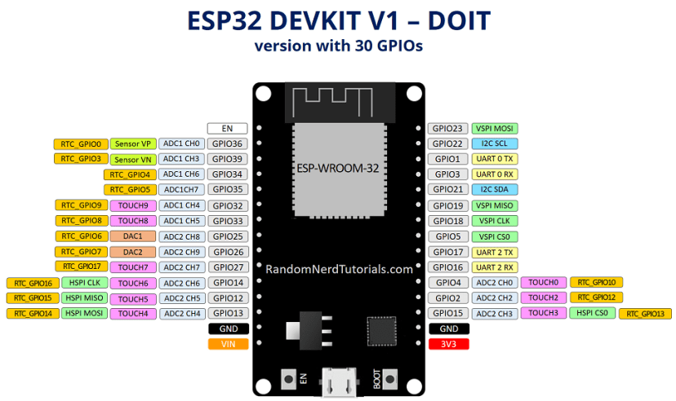

Source: <https://randomnerdtutorials.com/getting-started-with-esp32/>

You’ll have to read the device specifications/pinouts and connect them to the ESP’s pins accordingly.

#### Software

1. **Editing the data protocol.** We’ve already covered how to create different kinds of measurements. But the protocol we have in the code has its limitations: it can only capture a range of about 65,000 unique values. Let’s say you’re using a measurement with even more precision than that. Or, perhaps, your measurement is best represented as a base and an exponent, instead of a minimum value plus some number of increments. To capture this, you have a few different options.
   1. **Keep the SplitShort struct, and edit the conversion to and from floats**. Currently, the short_to_float and float_to_short functions assume we are using the SplitShort to represent the number of increments between the measurement’s minimum value and the measured value. To change the conversion, edit these two functions. The key idea is that *SplitShort is just two bytes: one high byte, and one low byte.* You can convert between floats and a pair of two bytes in any way you want. Here’s an example using scientific notation, which would represent 5,810 as 5.81x103 (you might have seen this on calculators as 5.81E3). We’ll use one byte for the significand (5.81) and one byte for the exponent (3). (This is actually how floats are already represented, but our version manually converts down to 2 bytes instead of 4!)

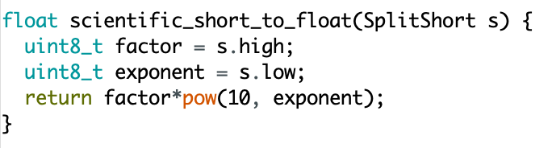

To convert back:

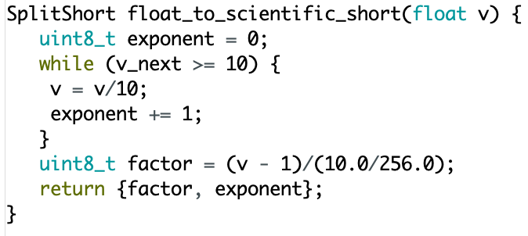

* 1. **Abandon the SplitShort struct entirely**. If you don’t want to use SplitShorts, and you’d rather use original data types like floats and ints, you’ll have to modify the code in a few places.
* Change the types of the arrays storing the data
* Change the read_sensors function to store in these news arrays directly, instead of converting types first
* Change post_sensors to take data from the new arrays instead of the SplitShort-compatible arrays
* The tricky part: edit sendDataMulti, which is used by the ESPNow functions to send data. The library function esp_now_send requires us to use a byte (uint8_t) array. If you’re using a different type, you’ll have to use memcpy to directly copy the bytes from your other data type into a uint8_t type array, and send that second array.